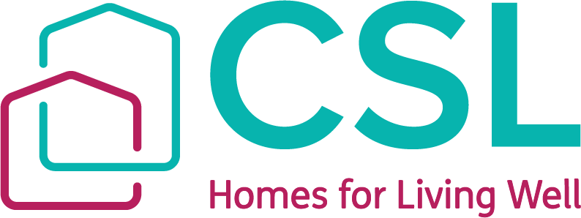
Annual Complaints Performance and Service Improvement Report
JULY 2025
Creative Support Ltd

April 2024 – March 2025
- Introduction
In February 2024, the Housing Ombudsman Service published an updated Complaint Handling Code, applicable from 1st April 2024. The Code aims to enable social landlords to better manage their complaints and promote a positive complaints culture.
The Code requires that social landlords annually self-assess against the Code, to engage their Governance in that exercise and to then publish the outcome. The Code further requires that social landlords produce an annual complaints performance and service improvement report for scrutiny and challenge. This report should be reported to the social landlord’s governing body and published on the section of its website relating to complaints. The governing body’s response to the report must also be published alongside this.
This report is Creative Support’s second annual complaints performance and service improvement report, and covers the period of 1st April 2024 to 6th April 2025. The report analyses all housing related complaints received in relation to accommodation directly owned by Creative Support and is based on data also published online for tenants as part of the Regulator of Social Housing requirements.
- Analysis of the Complaint Handling Performance (Directly Owned Accommodation Only)
Month | Number of Property Related Complaints | Number of Anti-Social Behaviour Related Complaints | Total Number of Complaints
April 2024 | 1 | 1 | 2
May 2024 | 0 | 2 | 2
June 2024 | 0 | 2 | 2
July 2024 | 0 | 2 | 2
August 2024 | 1 | 1 | 2
September 2024 | 1 | 1 | 2
October 2024 | 0 | 2 | 2
November 2024 | 6 | 2 | 8
December 2024 | 1 | 1 | 2
January 2025 | 1 | 0 | 1
February 2025 | 1 | 1 | 1
March 2025 | 0 | 1 | 1
TOTAL | 12 | 16 | 28

Overall Total | Percentage Property Related Complaints | Percentage Anti-Social Behaviour Complaints
28 | 43% | 57%
Type of Complaint |  |  | Total | Percentage
Noise Nuisance |  |  | 6 | 22%
Delays Completing Repairs / Works |  |  | 5 | 19%
Verbal and Physical Aggression |  |  | 6 | 22%
Visitors Behaviour |  |  | 3 | 11%
Heating (not working) |  |  | 4 | 14%
Damp and Mould |  |  | 1 | 3%
Pest Control |  |  | 1 | 3%
Condition of Gardens / Grounds / Trees |  |  | 1 | 3%
Complaints about Contractors |  |  | 1 | 3%
TOTAL |  |  | 28 | 100%

Type of Complainant | Total | Percentage
Tenant in our property | 15 | 54%
External Neighbour / Member of the Public | 7 | 25%
Relative | 6 | 21%
Other | 0 | 0
Visitor | 0 | 0
TOTAL | 28 | 100%

- Comparison with Previous Years Data

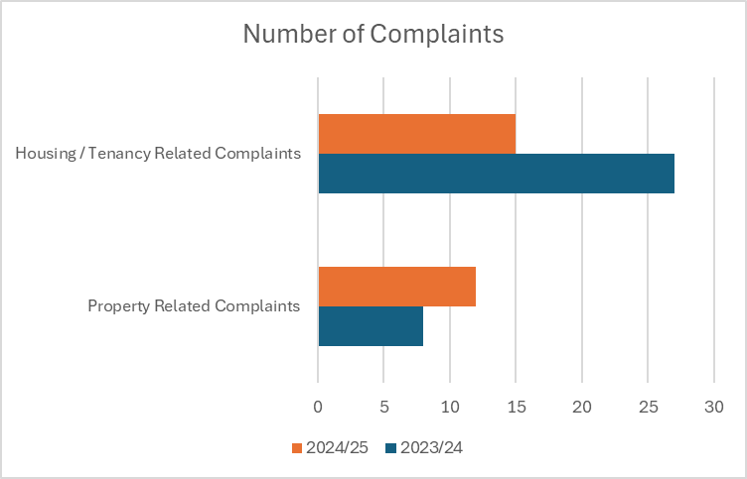

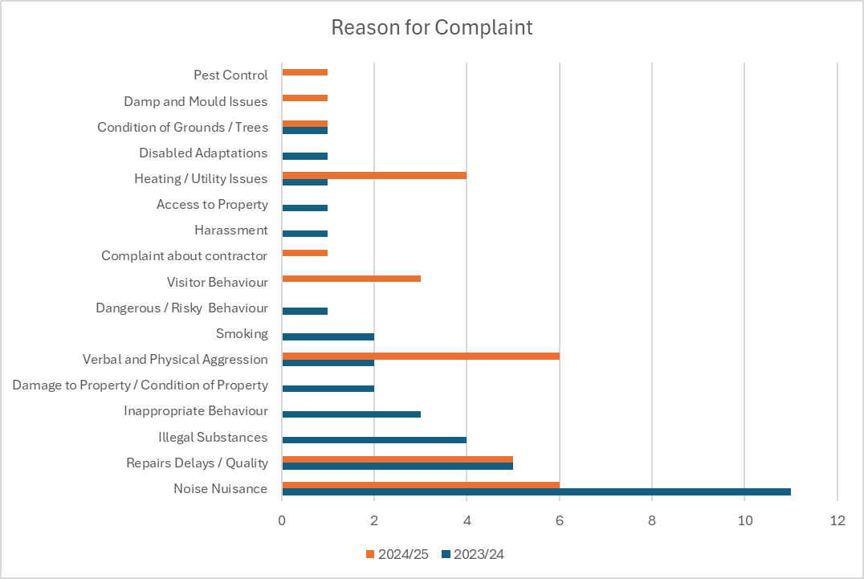

- Outcomes and Response to Complaints within the Target Timescale
Stage 1 Complaints
All complainants received a written outcome in response to the concerns they raised. They received an initial acknowledgement of their complaint within 5 working days. We aim to investigate and respond to complaints within 10 working days where possible. Where it will not be possible to deal with the complaint within the 10 days, we will offer an explanation and a date by which the response can be expected.
Of the 28 complaints we received, 27 were investigated, responded to and closed within the 10-day timescale. One complaint was responded slightly outside of the required timescale – by one additional day.
Stage 2 Complaints
One complaint escalated to Stage 2. The complainant received a written outcome in response to the concerns they raised within the 20-day timescale required for Stage 2 complaints. A brief summary of this case is below for information.
Tenant complaint about utilities not working at the start of the tenancy (July 2024), and a visitor being banned from the property. Complaint was not upheld. The tenant contacted the Housing Ombudsman who asked us to escalate the complaint to stage 2. At stage 2 the complaint was part upheld and compensation offered in respect of the utilities. The tenant declined this and has asked the Housing Ombudsman to investigate further. This is pending an outcome from the Housing Ombudsman.
Summary of Complaints We Refused to Accept
We had one complaint during the reporting period which we chose not to accept. The tenant was in the process of being evicted due to serious anti-social behaviour including property damage, threatening to kill / harm staff and contractors and stalking a staff member to his home. He was admitted to hospital for a period of time during which he was placed on a section 3 due to a deterioration in his mental health. During this time, he raised a complaint. He did not agree that we were serving him notice and felt that we should instead buy him a property to live in. He also stated that staff (frontline and Head Office staff) were intimidating him, sending Police to knock on his door and installing cameras in his property.
We did not feel this was a complaint which needed further investigation. The tenancy has since ended and the tenant has moved to other accommodation.
- Findings of non-compliance with Complaints Handling Code by the Ombudsman
We have had no findings of non-compliance with the Complaints Handling Code during this reporting period.
- Reports about our Performance from the Ombudsman
We have received no reports during this reporting period from the Ombudsman.
- Service Improvements made as a Result of Learning from Complaints
We have sought to ensure that we maintain good contact with complainants throughout the process of investigating their complaints and seeking resolution. We note that the majority of our complaints continue to come from our tenants. We ensure that support staff onsite are also aware of any complaints and can offer support to the tenant if needed e.g. in explaining or communicating their concerns.
Where there are delays in completing work, we have improved our communication with tenants to let them know what the delays are, why there are delays and how we will resolve this. Where possible we also try to give timescales, but often we have to wait for external contractors to confirm availability.
With complaints about repairs issues, we make sure we follow up with tenants after the work is completed to ensure they are happy with the work and that we can take action promptly if not, to avoid future complaints.
Noise nuisance continues to be one of the main reasons for complaints. These complaints included loud music and shouting in the communal areas / street / garden. A lot of these complaints are often one-off complaints about someone who was noisy on a particular day / a few days. We have found that with a written warning or a visit from the Housing Officer, these incidents are not repeated and there are no further complaints.
However, some of the complaints have related to ongoing anti-social behaviour issues and in some cases where we are seeking possession. In those instances we may see repeated complaints. We encourage the use of noise logs and other ways of evidencing the noise that occurs. We seek to reassure complainants we are doing everything we can to resolve the issue, within the boundaries of confidentiality. We try to be visible and easy to reach for complainants, so that they know we are listening. In one particular case where the neighbours were all being disturbed by our tenant and his visitor, we have been out to visit all the external neighbours on two separate occasions and also supported them to liaise with the Police to try and reassure them that action was being taken. We continue to maintain contact with them as we try to resolve the issue.
We also look at other ways we can resolve cases either by supporting the perpetrator to minimise the impact, or by offering the complainant other solutions. For example, in one case due to persistent issues with a tenant playing her music loudly, we were able to move the tenant who was experiencing the nuisance to another flat in the property which was away from the noise and resolved the immediate issue and actually, the other tenant has now stopped playing her music so loud following intervention from a care team.
All property and tenancy related complaints continue to go through one central point, separate to complaints related to our care and support. These are then triaged to the Head of Property or the Head of Housing, to ensure a suitably senior and qualified person addresses all complaints and within the required timescale. However, in some tenancy related complaints, we have benefitted from joint working with the Customer Care Team as some complaints may overlap with the support side of the organisation.
We continue to report to the Board of Trustees every 2 months on any complaints we have received, what they were about, what we did to resolve the complaint and any learning we took from the complaint.
9. Annual Self Assessment
We have self-assessed against the Complaint Handling Code and this self-assessment is also attached to this report.

