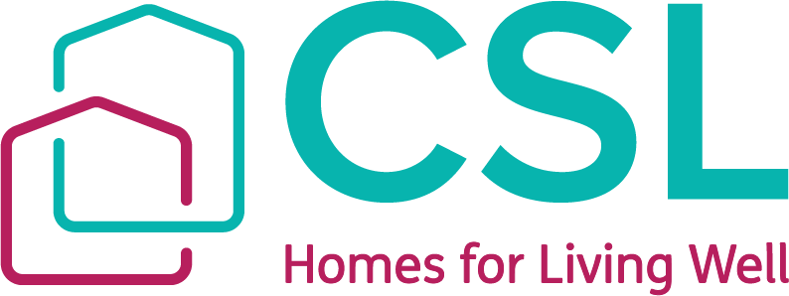
Annual Complaints Performance and Service Improvement Report
Board of Trustees Response
SEPTEMBER 2025
Creative Support Ltd
Board of Trustees Response
The Board of Trustees for Creative Support have reviewed the annual complaints performance and service improvement report and the self-assessment that has been completed against the Complaints Handling Code.
We are pleased to see that Creative Support has managed all complaints between April 2024 and March 2025 in line with the Complaints Handling Code, and also, their own corporate Housing Complaints and Compliments policy.
We believe that the organisation has a positive attitude towards complaints handling and seeking good outcomes for residents. It is important that our residents to feel comfortable raising their concerns where they are not satisfied with their experience. We felt as Trustees that it was therefore a positive indicator that the majority of complaints during this period were made direct by our residents.
We acknowledge that the majority of complaint relate to anti-social behaviour but that these complaints also tend to come from residents, rather than external complainants. We believe that this demonstrates Creative Support is working hard to manage instances of anti-social behaviour and to minimise the impact of these on members of the public, family and others.
We are pleased to observe that there was a low level of complaints during the 12 months, and in fact a reduction from the previous year. Further, we were happy to see that all complaints except one were resolved at stage one and that further to this, Creative Support has not had any cases of non-compliance or cases referred to the Housing Ombudsman.
We are confident that Creative Support has good oversight of the complaints they receive and are happy to see a commitment by Officers of Creative Support to continue improving their response to complaints.
We review all housing related complaints with Officers every two months as part of our Board of Trustees Housing committee, and believe the report accurately reflects the complaints that we have been made aware of. We have committed to continue reviewing all housing related complaints, as a Board of Trustees every two months.

Creative Support Board of Trustees

