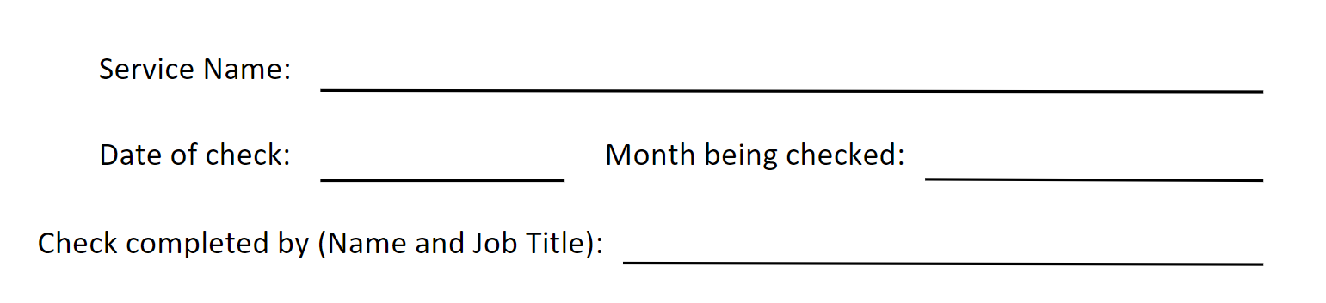

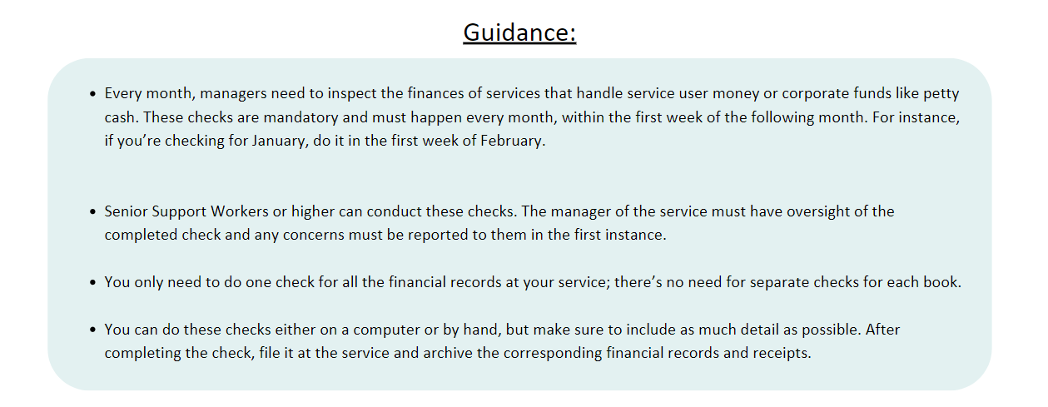

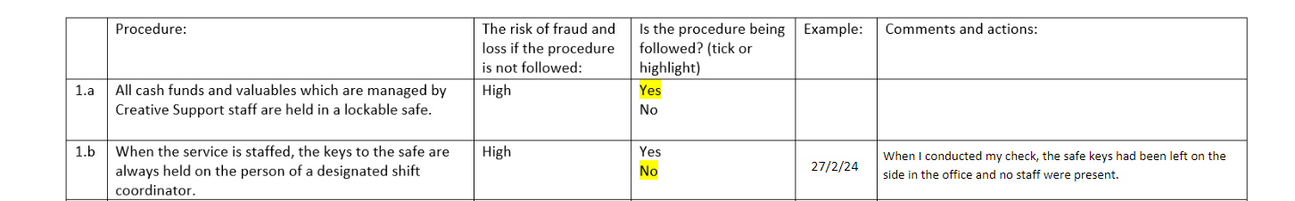
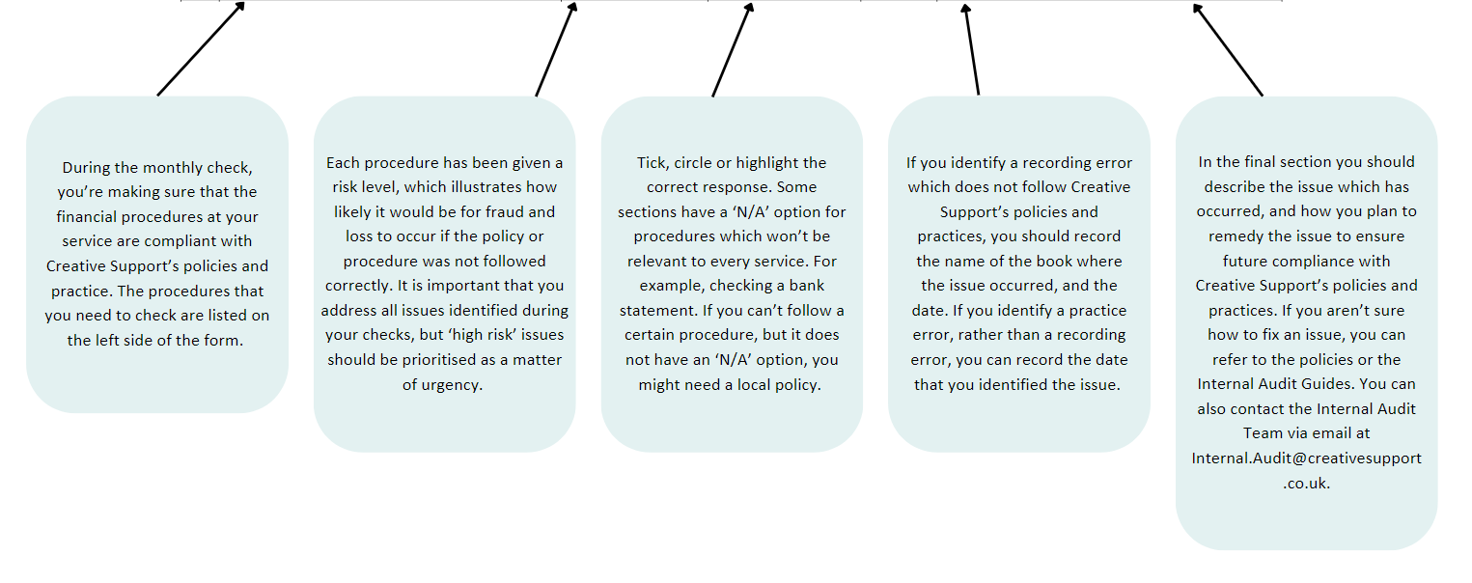
- Storage and security- To complete this section you will need to access the keys for the safe, and any money tins inside. You will also need access to the ‘Safe Contents Book’ and ‘Weekly Safe Check Book’.

 | Procedure: | The risk of fraud and loss if the procedure is not followed: | Is the procedure being followed? (tick or highlight) | Example: | Comments and actions:
1.a | All cash funds and valuables which are managed by Creative Support staff are held in a lockable safe. | High | Yes  No
1.b | When the service is staffed, the keys to the safe are always held on the person of a designated shift coordinator. | High | Yes  No
1.c | When the service is not staffed, the keys to the safe are held in a PIN-coded key safe which can only be accessed by senior staff members. | High | Yes  No
1.d | All non-cash valuables within the safe are recorded in a Safe Contents Book, including bank and pre-paid cards. | High | Yes  No  N/A
1.e | The Safe Contents Book accurately reflects the contents of the safe.  Tip: To check this, check for items listed in the 'items in' column of the safe contents book without corresponding entries in the 'items out' column. These items should be present in the safe. | High | Yes  No  N/A
1.f | Weekly safe checks are being completed and recorded in a ‘Weekly Safe Checks’ book. | High | Yes  No  N/A
1.g | If they are written down, PINs for bank or pre-paid cards are held in a separate, lockable location to the card. | High | Yes  No  N/A

- Recorded transactions: To complete this section you will need to access to all cash funds at the service, alongside the corresponding money books, receipts and folios.
 | Procedure: | The risk of fraud and loss if the procedure is not followed: | Is the procedure being followed? (tick or highlight) | Example: | Comments and actions:
2.a | All cash funds are recorded in an appropriate Creative Support money book. | High | Yes  No
2.b | Withdrawals and payments made using a pre-paid or bank card are recorded in a bank card book. | High | Yes  No  N/A
2.c | Staff record deposits and withdrawals from all funds as they occur, not retrospectively.  Tip: You can easily spot retrospective recording by looking for specific or exact amounts being recorded in the ‘money out’ column. E.g. £9.99 rather than £10.00. If you spot this, check the receipt to see how much cash was withdrawn to pay for the items, and how much change should have been returned. | High | Yes  No
2.d | Expenditure recorded in money books is always relevant to the fund. | High | Yes  No
2.e | All of the correct columns are completed when transactions are recorded. | Medium | Yes  No
2.f | Transaction descriptions are sufficiently detailed and language is appropriate.  Tip: Staff should avoid using vague terms like 'money in' and 'money out' for transaction descriptions.  Staff should also reserve 'personal money' for transactions where cash has been directly handed to a service user, who has provided a signature as evidence. “Pocket money” or similar language is not appropriate for describing this type of transaction. | Medium | Yes  No
2.g | Figures and dates are correct and recorded in full.  Tip: Figures should be written to two decimal places (‘£2.00’ not £2) and dates must include day/month/year. | Medium | Yes  No
2.h | Both of the required signature columns have been completed.  Tip: where a second staff member is not available, ‘lone working’ should be indicated. | Medium | Yes  No
2.i | Contributions to joint funds are recorded on individual rows. | Low | Yes  No  N/A
2.j | Loans have not been made to service users by staff, or from any fund other than Petty Cash. | High | Yes  No
2.k | All loans made from Petty Cash have been repaid in a timely manner. | Medium | Yes  No  N/A

- Receipts and Folios When you have confirmed the accuracy of a folio, you should sign the ‘passed by’ section to evidence your check.
 | Procedure: | The risk of fraud and loss if the procedure is not followed: | Is the procedure being followed? (tick or highlight) | Example: | Comments and actions:
3.a | Receipts and folios are present for each recorded purchase. | High | Yes  No
3.b | Receipts and folios are numbered, starting from 1 at the beginning of each month (except petty cash), and recorded in the ‘v’ column of the book. | Medium | Yes  No
3.c | Petty Cash receipts and folios numbered starting from 1 after each requisition. | Medium | Yes  No
3.d | Staff have refrained from using their own bank cards or personal loyalty cards on the receipt. | High | Yes  No
3.e | Staff meals are indicated on the corresponding receipt, and are within the limits.  Tip: the limits are £3.00 breakfast, £6.00 lunch, £10.00 evening meal. | High | Yes  No  N/A
3.f | Shared purchases are made using a joint fund, and benefit all contributing service users. | Medium | Yes  No  N/A

- Checks and balances: You may wish to use a calculator to complete this section.
 | Procedure: | The risk of fraud and loss if the procedure is not followed: | Is the procedure being followed? (tick or highlight) | Example: | Comments and actions:
4.a | All cash funds are balanced and checked at least once a day, in addition to any transactions that are recorded. | High | Yes  No
4.b | Page total checks are completed at the bottom of each page, correctly and in full, by the person who completed the final transaction on the page.  Tip: to confirm the accuracy of the page total complete the following calculation (opening balance + total money in- total money out = page total). | Medium | Yes  No
4.c | Calculations with the balances are updated accurately.  Tip: Use the above calculation to confirm that balances have been updated accurately. If the calculated total matches the recorded page total, the calculations on the page are correct. If not, cross-check each transaction with the corresponding receipts to ensure accurate calculations. | High | Yes  No
4.d | The staff team identifies discrepancies and records them in the comments box. | Medium | Yes  No
4.e | Any discrepancies or incidents of missing money have been reported via incident report.  Tip: Any financial discrepancies should be reported to a senior staff member as soon as they are identified. Any incidents of missing money should be submitted to the accidents and incidents via an Incident Report. | High | Yes  No  N/A
4.f | Pre-paid card balances are checked and recorded on a weekly basis. | High | Yes  No  N/A
4.g | Service user’s bank/card statements are checked against their bank/pre-paid card.  Tip: If you do not have access to the bank statements, please confirm that they are being regularly checked by their designated third party i.e. their appointee, power of attorney or court of protection etc. | High | Yes  No  N/A

- Financial Arrangements: You can update the Financial Arrangements Register with the Internal Audits team.
 | Procedure: | The risk of fraud and loss if the procedure is not followed: | Is the procedure being followed? (tick or highlight) | Example: | Comments and actions:
5.a | All financial arrangements at the service have been disclosed to the Financial Arrangements Register and are up to date. | High | Yes  No

- Finance Files: You only need to complete this section if service users receive formal financial support at the service. You can find the ‘Finance file contents page’ on the Internal Audits page of the staff area.
 | Procedure: | The risk of fraud and loss if the procedure is not followed: | Is the procedure being followed? (tick or highlight) | Example: | Comments and actions:
6.a | All service users who receive formal financial support have a finance file at the service. | High | Yes  No  N/A
6.b | All finance files include evidence of a financial capacity assessment and best interest decision, as well as the details of any registered third parties who offer financial support such as appointees, LPAs etc. | High | Yes  No  N/A
6.c | All finance files contain signed permission forms to hold funds. | High | Yes  No  N/A
6.d | Budget plans are in place and up to date.  Tip: Budget Plans should be updated yearly. | Medium | Yes  No  N/A
6.e | Inventories are in place and up to date. | Low | Yes  No  N/A
6.f | Where applicable, finance files contain benefit letters. | Medium | Yes  No  N/A
6.g | Where applicable, finance files contain copies of bills. | Medium | Yes  No  N/A
6.h | Where applicable, bank statements are held on file. | High | Yes  No  N/A
6.i | Where applicable, signed Equals Card agreements are held on file. | High | Yes  No  N/A
6.j | Finance files contain information about large purchases (£500.00 and over) including evidence that three quotes were obtained, and that the service user was consulted. | Medium | Yes  No  N/A

- Archiving: You will need access to the archived money books to complete this section.
 | Procedure: | The risk of fraud and loss if the procedure is not followed: | Is the procedure being followed? (tick or highlight) | Example: | Comments and actions:
7.a | Money books and receipts from the previous months have been archived (except for petty cash). | High | Yes  No
7.b | 12 months’ worth of archived money books are easily accessible at the service. | Medium | Yes  No

- Service user mileage: You only need to complete this section if you support any service users who own a vehicle.
 | Procedure: | The risk of fraud and loss if the procedure is not followed: | Is the procedure being followed? (tick or highlight) | Example: | Comments and actions:
8.a | Any journeys made using a service user’s vehicle have been documented in a Mileage Book. | High | Yes  No  N/A
8.b | The journeys documented in the book correspond with the mileage of the vehicle.  Tip: Use Google Maps to confirm whether the distance travelled corresponds with the mileage used on the vehicle. | Medium | Yes  No  N/A
8.c | Receipts are present for fuel purchases. | Medium | Yes  No  N/A

Service users in staff vehicles: You only need to complete this section if service users are being driven by staff members in their personal vehicle. Please note, in line with the Escorting Service Users in Staff Vehicles Policy, this is generally prohibited except at Day Support services, or in cases where an exemption has been permitted.
 | Procedure: | The risk of fraud and loss if the procedure is not followed: | Is the procedure being followed? (tick or highlight) | Example: | Comments and actions:
8.d | (Unless you are a day service) An exemption form has been completed to authorise any journeys made using a staff member’s personal vehicle.  Without this, it is not permissible for a staff member to use their personal vehicle to transport service users under any circumstances. The form must be authorised for it to be valid. | High | Yes  No  N/A
8.e | In all instances where these journeys have taken place, service users have paid the appropriate contribution for fuel in cash (£1.00 per 1 mile) and this has been recorded in a Fuel Contribution Book. | Medium | Yes  No  N/A
8.f | All cash contributions are being banked at Head Office on a monthly basis. | Medium | Yes  No  N/A

- Large purchases: This section applies to any large purchases including holidays, vehicles, furniture, and electronic devices.
 | Procedure: | The risk of fraud and loss if the procedure is not followed: | Is the procedure being followed? (tick or highlight) | Example: | Comments and actions:
9.a | A minimum of three comparison quotes have been obtained for any purchases over £500.00. | Medium | Yes  No  N/A
9.b | There is evidence to confirm the service users were consulted on the large purchase.  e.g. Best Interest Decisions, Person Centred Support Plan, Summaries of Work. | Medium | Yes  No

Service user holidays: You only need to complete this section if a service user holiday has been planned/purchased in the last month.
9.c | Both the Consultation Form and My Perfect Holiday documents were completed prior to completing the Holiday Proposal Form. | High | Yes  No
9.d | The destination for the holiday is reflective of the service user’s wishes outlined in the My Perfect Holiday document.  e.g. if the service user has explained they like hot holidays, the holiday destination is in a hot location. | High | Yes  No
9.e | A minimum of three comparison quotes have been obtained for the holiday.  e.g. comparing flight, hotel, travel prices. | High | Yes  No
9.f | A Holiday Money Book has been created to document all of the service user’s expenditure whilst on holiday. | High | Yes  No
9.g | The budget for the holiday has been agreed by the service user or their designated third party.  e.g. their appointee has approved how much is within their budget to spend on the holiday. | High | Yes  No
9.h | The completed Holiday Proposal form, and all other accompanying documentation for the holiday, is held within the service user’s finance file. | Medium | Yes  No
9.i | A contingency fund has been agreed with the service user or their designated third party.  e.g. this is a fund to be taken on holiday and only used in emergencies. | Medium | Yes  No
9.j | The staffing at the service has been considered when planning the service user holiday.  e.g. taking into account whether there are any banked/contingency hours which may be used. | Medium | Yes  No
9.k | The chosen holiday accommodation has been assessed for accessibility access if required.  e.g. it has been adapted for wheelchair use or has assist grab bars. | Medium | Yes  No  N/A
9.l | Cancellation insurance has been purchased for the holiday.  Tip: check if this is already included in the holiday package. If not, it will need to be purchased separately. | High | Yes  No
9.m | Travel health insurance has been purchased for the holiday.  Tip: not all countries accept the GHIC (Global Health Insurance Card) so insurance will need to be purchased. Visit Foreign travel insurance - GOV.UK (www.gov.uk) for more guidance on this. | High | Yes  No
9.n | The service user’s travel documentation is up to date and valid.  e.g. passport. Many countries will only allow entry if you have at least 6 months validity remaining on your passport. Don’t forget to check the passport of the staff accompanying the service user as well! | High | Yes  No

