Prints of Africa & Aboriginal Art – Black History Month at Creative Together

In celebration of Black History Month this October, Creative Together would like to show you the art we have created, focusing on the themes of Prints of Africa and Aboriginal Dot Art.
Using art and textile prints from different countries across the continent of Africa, our members found inspiration to create their own prints. We then collated these wonderful prints into a larger patchwork, so we could highlight their talent and hard work.
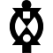
We also learnt a lot along the way- discovering that these vibrant prints are used in a wide variety of art and textiles, and hold a lot of cultural and historical significance. Our members were encouraged to incorporate Adinkra symbols from Ghana used in fabrics, pottery, and logos, as well as featuring in walls and architectural features. These symbols represent concepts and ‘pearls of wisdom’, such as courage, understanding, and endurance.
BOA ME NA ME MMOA WO
“Help me and let me help you”
Represents cooperation and interdependence

We have also been learning about “Aboriginal Dot Art”. Aboriginal Australians are the various Indigenous peoples of the Australian mainland, with various mobs – meaning tribes – living throughout Australia. Each mob has its own unique beliefs but all Aboriginal cultures have a strong connection to the land. Their traditional cultures and beliefs are passed down and shared by dancing, stories, songlines and art – also known as Dreamings.
The Aboriginal peoples would usually pass down these stories and rituals by drawing symbols in the sand or on their bodies. Once finished, they would smooth over the sand or wash their bodies in order to preserve their culture, their stories, and their secrets.
In 1972, an arts organisation called Papunya Tula, owned and operated by Aboriginal people from the Western Desert, innovated the very recognisable “dot painting”. They conveyed their Dreamings by repeating dots of paint, usually around symbols or drawings of animals and other such things from nature. The dotting method was developed as a way to obscure the painting underneath, and therefore the true, sacred, and often secret meaning.
In our Arts & Catch Up session, our members were asked to choose out of a selection of templates featuring various animals indigenous to Australia – kangaroos, snakes, koalas. They then were free to choose their own colours and dot designs, whilst being encouraged to incorporate Aboriginal symbols. These symbols, much like a language, depict different elements of everyday life for the Aboriginal peoples – rivers, mountains, kangaroo tracks, etc.
Our final piece is a collaborative one. Some of our members graciously accepted to have their handprints incorporated into a larger work of art. Picking out symbols that I felt represented our members and the city of Manchester, I incorporated all of the elements onto this large design – done on a piece of unwanted cardboard to give respect to Aboriginal peoples’ love of the land and wish to preserve it. See you if you can pick out the symbols and guess what they mean!
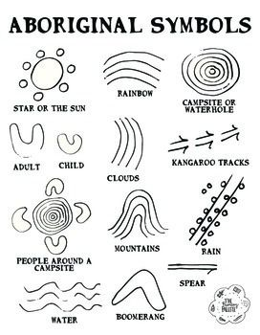
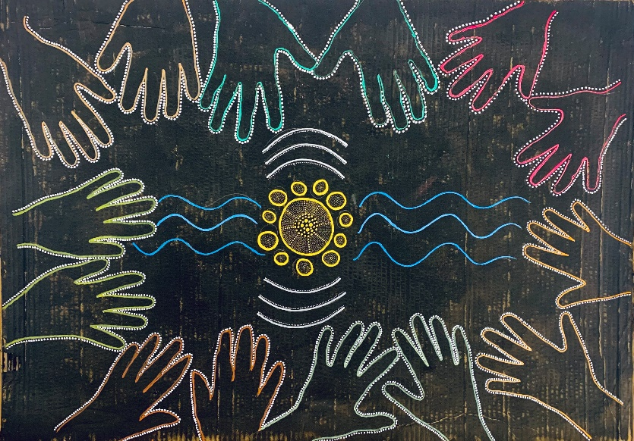
Main design by Bex featuring hands of Creative Together Members

Examples of dot paintings and photos of Aboriginal people designing in the sand:
