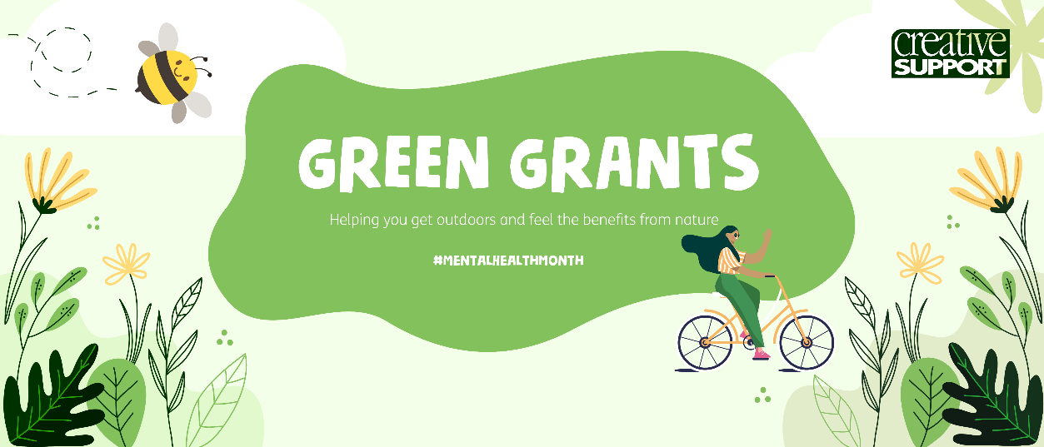

Contact Details
Name: Job Title:
Email: Phone Number:
Name and Address of Service:
Number of Service Users at your Service:
Your ‘Green Your Service’ Grants

We are offering 5 grants of up to £1,000 to help get your outdoor space looking and feeling beautiful for everyone to enjoy! This could be money towards accessibility gardening beds at your service, wheelchair safe access, disabled swings, starting your own gardening group, funding some gardening training, setting up an allotment, and more.
Please detail below, in no more than 500 words, what you would like to spend the money on and how it will help you and your service become greener, and work more nature into your life! Please include an estimated individual breakdown of items you will be purchasing.

