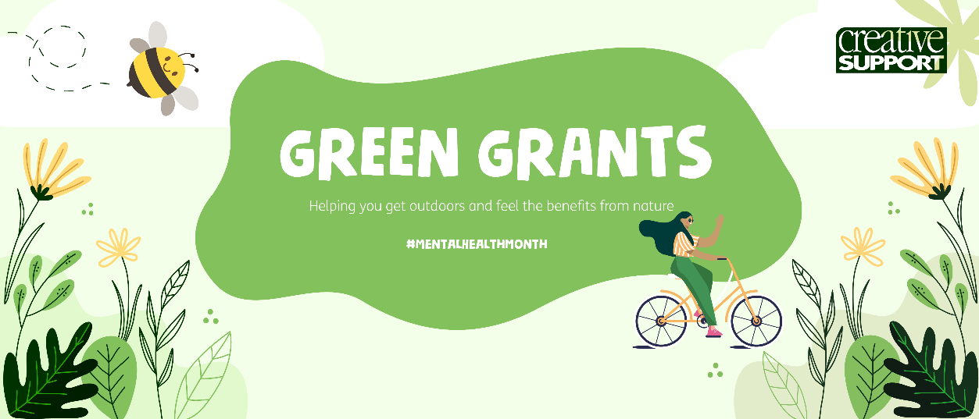

Contact Details
Name: Job Title:
Email: Phone Number:
Name and Address of Service:
Your ‘Green Your Life’ Grants

We’re offering 15 grants of up to £100 to help you get into nature. You can use this funding to buy bird feeders, new plants, a bike to help you get into nature or even use the money towards a train ticket or a hotel somewhere near nature such as The Lake District.
Please detail below what you would like to do with the money, how much it will cost and how it will help you into the great outdoors.

